Agenda November 10, 2020

City Council City of Flatonia

Council Chambers/City Hall Regular Meeting
125 E. South Main, Flatonia, Texas 6:00 p.m.

Notice of City Council Meeting

In accordance with the provisions of the Texas Open Meetings Act, Chapter 551, Texas Government Code, Notice is hereby given that a Regular Meeting of the City Council of the City of Flatonia will be held on Tuesday, November 10, 2020 beginning at 6:00 p.m. in the City Hall Council Chambers located at 125 E. South Main St., Flatonia, Texas, for the purpose of considering the following agenda items:

The meeting agenda is posted online at: http://www.flatoniatx.gov/page/Council_Agendas_Minutes

Members of the public who wish to submit their written questions or comments on a listed agenda item must submit these by sending an email to City Manager Sarah Novo at manager@ci.flatonia.tx.us. Questions or comments must be received no later than 12:00 noon on Tuesday, November 10, 2020.

Opening Agenda

Call to Order
Invocation & Pledge
Citizens’ Participation

Reports

Police Department Activity Report October 2020

Utility Department Activity Report October 2020

Consent Agenda
Approve minutes of the October 13, 2020 Regular Council Meeting.

Deliberation Agenda

11.1.2020.1 Consider and take appropriate action on the appointment of Taylor Laney to the Economic Development Board.

11.1.2020.2 Consider and take appropriate action on the commercial property lease executed by and between the City of Flatonia and the Flatonia Chamber of Commerce.

11.1.2020.3 Consider and discuss the Chamber of Commerce holiday events to include Christmas in Flatonia and Wine Walk.

11.1.2020.4 Consider and take appropriate action on an ordinance amending article 1.06 of the Code of Ordinances, City of Flatonia, establishing the office of City Secretary.

11.1.2020.5 Consider and take appropriate action on approval of City Manager appointment of Angela Walton as the City Secretary of the City of Flatonia.

11.1.2020.6 Consider and take appropriate action on items included in report from City Manager Novo.

11.1.2020.7 Consider and take appropriate action on procedures and enforcement of the City of Flatonia Code of Ordinances.

Adjournment

I, the undersigned authority hereby certify that the Notice of Meeting was posted on the bulletin board outside the front door of the City Hall of the City of Flatonia, Texas, a place convenient and readily accessible to the general public at all times and said Notice was posted on the following date and time Friday, November 6, 2020 by 6:00 p.m. and remained so posted continuously for at least 72 hours preceding the scheduled time of said meeting.

Sarah Novo, City Manager, City of Flatonia

EXECUTIVE SESSION STATEMENT

The City Council reserves the right to adjourn into executive session at any time during the course of this meeting to discuss any of the matters listed above, as authorized by the Texas Government Code, Section 551.071 (Consultations with Attorney), 551.072 (Deliberations about Real Property), 551.073 (Deliberations Regarding Gifts and Donations), 551.074 (Personnel Matters), 551.076 (Deliberations Regarding Security Devices or Security Audits), 551.086 (Certain Public Power Utilities: Competitive Matters) and 551.087 (Deliberation Regarding Economic Development Negotiations).
NOTICE OF ASSISTANCE
AT THE PUBLIC MEETING

The Flatonia City Hall is wheelchair accessible. Access to the building is available at the primary entrance facing Main Street. Persons with disabilities who plan to attend this meeting and who may need auxiliary aids or services such as interpreters for persons who are deaf or hearing impaired, readers, or large print are requested to contact the City Manager’s Office at 361-865-3548 or by FAX 361-865-2817 at least two working days prior to the meeting so that appropriate arrangements can be made.

FLATONIA POLICE DEPARTMENT
205 E. South Main St. Flatonia, TX 78941 Office: 361-865-3337 Fax: 361-865-3039
October Monthly Report

To: Flatonia City Council

From: Flatonia Police Department

Subject: October Monthly Report

Calls for Service:

There were 227 calls for service for this month.

Offense / Incident Report Activity:

10/01/2020 Officer Llanes observed a stranded vehicle at the intersection of I-10 feeder and FM-609. Officer Llanes was able to speak to the driver who stated his vehicle had broken-down and he needed to get it towed to his residence. Officer Llanes provided traffic control and the vehicle was towed out of the intersection and to the owner’s residence.

10/03/2020 Officer Kucera received a call regarding a welfare concern. The complainant stated she was receiving emergency alerts to her phone from a family member in Flatonia and was very concerned for his safety. Officer Kucera was able to contact the family member’s place of employment and he left a message for the family member to contact the complainant to let her know that he was safe. Normal patrol duties resumed.

10/05/2020 Chief Dick and Sgt. Pritchard responded to multiple fires located on I-10. Chief Dick used his fire extinguisher to keep the fire from crossing over to the other side of the freeway, until the Flatonia Fire Department arrived shortly thereafter. Flatonia Police Officers and a Fayette County Deputy provided traffic control as the Flatonia Fire Department extinguished the fires. Chief Dick drove one of the responding Flatonia Fire Department brush trucks to assist the fire department. The normal flow of traffic resumed.

10/05/2020 Officer George was contacted by a local resident about a scam telephone call. The resident stated that someone, claiming to be from the Social Security Administration, had called her and asked her to verify her Social Security Number. The resident said she did not give them any information and hung-up. She then contacted the Flatonia Police Department immediately. Officer George explained to her that she did the right thing by not providing any information to the caller and then notifying law enforcement.

10/08/2020 Officer Stansberry was dispatched to a local convenience store in reference to a female that appeared to be lost. Upon arrival, Officer Stansberry contacted the female, who stated that she was lost and needed to get to Taylor, Texas. Officer Stansberry contacted a family member who said he would be on his way immediately to pick her up. The lady was picked up safely and Officer Stansberry returned to his patrol duties.

10/10/2020 Officer George provided traffic control for the Flatonia High School Rotary Interact Club as they picked up trash and debris along Interstate 10.
10/14/2020 Sgt. Pritchard answered a call about two suspicious subjects at a local business. The complainant stated that the subjects seemed to be intoxicated and expressed concern for their safety. After contact was made by Sgt. Pritchard, he was able to establish that the subjects were not impaired in any way, and simply stopped to get a few things at the store.

10/14/2020 Chief Dick responded to assist a Fayette County Deputy who stated that he was attempting to make a traffic stop of vehicle that had been reported as stolen, and the driver was refusing to stop. Almost immediately, the Deputy requested that EMS respond to the scene, where the vehicle had crashed. Chief Dick arrived on-scene where the vehicle had come to a stop and provided medical and law enforcement assistance until additional units arrived. He then departed the scene and returned to normal duties.

10/19/2020 Lieutenant Pritchard and Chief Dick responded to a call, in reference to a fall victim at the intersection of 8th St. and Hudson. The female was found sitting upright in her wheelchair and claimed that she had accidentally run into the front of a parked vehicle with her wheelchair. She refused Emergency Medical Services, but because she had several places on her arms and legs where skin was broken and bleeding, Chief Dick applied sterile dressings and wrapped the areas with gauze. Her family took her to her scheduled doctor’s appointment to have the wounds evaluated as part of the scheduled visit.

10/24/2020 During Patrol duties, Officer Llanes observed that the garage door to a local business was open after normal business hours. Officer Llanes contacted a male subject present at the location and identified him as an employee of the business who was working late. Patrol duties resumed.

10/25/2020 Flatonia Officers responded to a call in the 200 block of W. 5th Street regarding an elderly female who appeared to be lost and disoriented. The officers were able to identify the female and get her safely back to her residence and family.

10/27/2020 The Flatonia Police Department attended the annual Flatonia ISD trick-or-treat event, which was held inside the Civic Center this year. Officers staffed a table and passed out candy, stickers, and other items. The event was heavily attended and included numerous local businesses, citizens, city officials, school personnel, and civic organizations.

10/30/2020 Flatonia Officers responded to a verbal disturbance in the 500 block of E. 7th Street. The parties were separated, and no further action was taken.

10/30/2020 Officer Kucera responded to a two-vehicle accident at the intersection of State Highway 95 and the I-10 frontage road. Minor injuries were reported and both vehicles sustained damages but were able to be driven away from the scene.

10/31/2020 Officer Stansberry assisted Texas State Troopers with a vehicle pursuit that was approaching the Flatonia City limits. Officer Stansberry and Fayette County Deputies assisted by providing back up for the State Trooper until the scene was secured.

Code Enforcement

10/08/2020 It was brought to our attention that a location off the I-10 feeder road was soliciting renovation work without proper permits. Officer Kucera contacted the manager at the location and the manager stated the work solicitations were from the year before and that he currently had no work to be done to the property. The manager said he would be taking the ads down immediately.

10/09/2020 Lieutenant Pritchard received a call regarding a junk vehicle located on private property. The caller was advised of the appropriate way to deal with the situation, as this was private property and the vehicle belonged to a person living at the location. The matter was resolved a few days later.

10/13/2020 Complaints about tall grass/weeds at a property off Highway 90 were received. The owner of the property was contacted, and the matter was resolved within a few hours.

10/15/2020 Officer George observed a code enforcement violation in reference to tall grass on N. La Grange St. The owners were contacted and advised that their grass needed to be mowed. This matter was resolved through voluntary compliance.

10/19/2020 Lieutenant Pritchard was on patrol when she observed trash and debris located around a business off N. La Grange St. Contact was made with the manager of the business and advised that the trash needed to be picked-up in order to be in compliance with code enforcement regulations. The manager stated she would be getting someone to clean up as soon as she could. The matter was resolved through voluntary compliance.

10/22/2020 Officer Kucera received a complaint in reference to illegal burning at the 400 block of S. Colorado St. Officer Kucera contacted the residents of the home and observed that they were burning sticks in a burn barrel that was covered with a metal grate, which was in compliance with City Ordinance. Officer Kucera returned to patrol.

NO FURTHER DETAILED INFORMATION IS PUBLISHED DUE TO ON GOING INVESTIGATION OF CASES.

Arrests and Pending Charges

Due to Covid-19 restrictions put in place at the state and local levels, arrests for minor violations are being handled in different manners such as citations and written promises to appear.

Traffic Contacts: 41

Reserve Officers Work
Reserve officers worked a total of 0 hours.

In-Service Training:
32 Hours

Animal Complaints - 4 | Noise Complaints- 1 | Accidents - 1
Scam Calls - 1 | Disturbances - 1 | Transient Calls - 0
Close Patrol - 146 | Open Door -4 | Funeral Escorts -1
Alarm Calls -3 | Suspicious Activity/Person - 6 | Agency Assists - 17
Citizen assist - 17 | Suspicious Vehicle- 5 | Civil Matters - 3
Ministerial Vouchers -0 | Motorist assist - 2 | Welfare Check - 2
Inquest -0 | Traffic Hazards - 5 | Follow Ups - 1

Flatonia Police Department

Utility Report
October 2020

10/2
- Tracing unknown water line to source, off Slaughterhouse Rd
10/5
- Start city wide cleanup, chipping
10/6
- Trimming electrical ROW by school
- Supak now behind old Western Auto with sewer line
10/7
- Water samples
- Trimming electrical ROW by school
- Repair lights at civic center
10/10
- Started city wide cleanup collection
10/12
- 2 water leaks off of 5 Mile Creek Rd
- Trim electrical ROW on branch feeder off of 5 Mile Creek Rd
10/13
- Clear ROW for electrical line for Amigo’s Truck Wash
- Water tap for Amigo’s Truck Wash
10/16
- Finish water meter installation for Amigo’s Truck Wash
- Set transformer pole for same
10/19
- Set transformer bank and replaced inline pole at Amigo’s

10/20
- Started trimming and maintenance on Praha electrical feeder
10/21
- Replaced bad pole at Hwy 90 & FM 1295
10/22
- Clean up trimming at Praha
10/26
- Hook up temporary power to Amigos truck wash
- Hand deliver lead and copper results to customers
10/27
- Service equipment and stock vehicles
- Locate water main on Amigos property

Flatonia City Council
Staff Report
November 10, 2020 Council Meeting

CONSENT

Agenda Item: Approve Minutes of October 13, 2020 Regular Council Meeting

Recommended Motion: I move to approve the consent agenda to include the
minutes of the October 13, 2020 Special Meeting.

Minutes
Flatonia City Council
Regular Meeting
October 13, 2020
Present:
Mayor Bryan Milson
Councilpersons Catherine Steinhauser
Mark Eversole
Dennis Geesaman
Ginny Sears
Donna Cockrell
City Staff Sarah Novo – City Manager
Angela Beck – City Attorney
Lee Dick –Chief, Flatonia Police Department
Jack Pavlas – Director, Utility Director
Public Melanie Berger – Flatonia Argus
Allen Kocian
Beverly Ponder
Karen Milson

Mayor Milson called the Regular meeting to order at 6:00 p.m.

Mayor Milson led the invocation, the pledge to the American Flag and the pledge to the Texas Flag.

Public comment by Allen Kocian on Christmas in Flatonia and Wine Walk. Request from Council to return for November meeting so that further discussion can occur.

Reports

Police Department Activity Report September 2020

Utility Department Activity Report September 2020

Consent Agenda
Catherine Steinhauser made a motion to approve the minutes of the September 22, 2020 Special Council meeting. Mark Eversole seconded the motion. None opposed. Motion carried.

Dennis Geesaman made a motion to approve the Hotel Occupancy Tax Reports from the Flatonia Chamber of Commerce, E.A. Arnim museum and Archives, and Flatonia Special Projects. Catherine Steinhauser seconded the motion. Ginny Sears and Mark Eversole recused from the vote. None opposed. Motion carried.

Deliberation Agenda

10.1- 2020.1 Dennis Geesaman made a motion to aapprove a resolution reinstating , continuing and renewing the Declaration of Disaster as signed by Mayor Milson on March 24, 2020, ratified by Council on March 31, 2020 and continued by Council on March 31, 2020, May 27, 2020, and July 28, 2020 for an additional 60 days from October 13, 2020. Ginny Sears seconded the motion. None opposed. Motion carried.

10.1-2020.2 No action taken on City Manager report.

Executive Session

ES10.1-2020.1 Open 6:40 P.M.
As authorized by Texas Government Code Sec. 551.071 (Consultation with Attorney), the Council may enter into closed or executive session to consult with City Attorney about pending or potential litigation and claims, administrative hearings, settlement offers, or attorney-client privileged matters, including the following matter:
Perry Kram v. City of Flatonia, 2019V-151; 155th District Court, Fayette County, Texas
Closed 6:48 P.M.

ES10.2-2020.2 Open 6:48 P.M.
As authorized by Texas Government Code Sec. 551.072 (Deliberations regarding Real Property) and Sec. 551.071 (Consultation with Attorney), the Council may enter into closed or executive session to discuss acquisition of the following item of real property and to consult with City Attorney about attorney-client privileged matters relating to such acquisition:
1107 E. Highway 90, Flatonia, Texas
Closed 7:10 P.M.

ES10.2-2020.3 Open 7:12 P.M.
As authorized by Texas Government Code Sec. 551.074 (Deliberation regarding Personnel Matters) the Council may enter into closed or executive session to discuss the following personnel matter:
City Manager 6-month Performance Evaluation
Closed 8:33 P.M.
Deliberation

10.2-2020.3 No action taken on authorizing the City Manager to enter into negotiations regarding the acquisition of property located at 1107 E. Highway 90, Flatonia, Texas.

The meeting was adjourned at 8:37 P.M.
Flatonia City Council
Staff Report
November 10, 2020 Council Meeting

DELIBERATION 11.1.2020.1

Agenda Item: Consider and take appropriate action on the appointment of Taylor Laney to the Economic Development Board.

Recommended Motion: I approve the appointment of Taylor Laney to the Economic Development Corporation Board of Directors.

Flatonia City Council
November 10th, 2020 Council Meeting

DELIBERATION 11.1.2020.2

Agenda Item: Consider and take appropriate action on the commercial property lease executed by and between the City of Flatonia and the Flatonia Chamber of Commerce.

Discussion and Consideration:
- Section 5. Consider cost per hour to be in line with off-duty costs of police officers.
- Section 6. Renter’s insurance and liability insurance policies to be provided to the City within 30 days of the date of execution of this agreement.
- Section 6. Chamber to carry liability insurance for all events on City property with the City listed as additional insured.
- City to have first right of refusal for use of rooms in the Civic Center.
- Section 8. Discussion of City payment of 75% of utilities at the Civic Center.
- Section 10. Discussion of all Civic Center generated monies remaining with and used by the Chamber.
- Section 10. Discussion of the Chamber being the point of contact for all Civic Center rentals, contracts and fee collection.
- Review of rental contracts by City.
- Section 9. Discussion of City maintenance of interior and exterior of the Civic Center, and replacement of major mechanical and structural failures at the expense of the City.
- Building lease expense.

THE STATE OF TEXAS §

COUNTY OF FAYETTE §

COMMERCIAL PROPERTY LEASE

This Lease is made and executed by and between The City of Flatonia, hereafter called Lessor, and The Flatonia Chamber of Commerce, hereafter called Lessee.
Section 1.
Lessor leases to Lessee and Lessee hires from Lessor the office space, storage room and garage space in the southwest corner located within the premises described as the City of Flatonia Civic Center, and the lot thereon described as follows:
All that certain piece or parcel of land lying in and being situated in the City of Flatonia, Fayette County, Texas, fronting approximately eighty (80) feet on the east margin of Market Street and approximately two hundred (200) feet on the south margin of U.S. Highway 90, and having the dimensions of approximately eighty (80) feet by approximately two hundred (200) feet and containing within said boundaries approximately sixteen thousand (16,000) square feet.
Such parcel of land being part of two tracts of land conveyed from Southern Pacific Company to The City of Flatonia, Texas by deed registered in Volume 411, Page 306 of the Fayette County deed records.
Section 2.
The term of this Lease is three (3) years commencing the 12th day of December, 2017 and ending the 30th day of November, 2020.

Section 3.
Rent due under this Lease is in the amount of $1.00 per year, shall be paid beginning on the 1st day of January, 2018 and continuing thereafter for two more consecutive years by the 1st of January.
Section 4.
The premises are to be used for Flatonia Chamber of Commerce business purposes. Lessee agrees to restrict its use to such purposes and not to use, or permit the use of, the premises for any other purpose without first obtaining the consent in writing of Lessor. Lessor has the authority to designate the opening of the two main front doors, the interior hallway and both the men’s and women’s restrooms for public use at hours to be set by the City Manager.
Section 5.
SECURITY: Any use of the Civic Center by a third party approved by the Lessee requires security as outlined in the following:
- For any function where more than 100 people are gathered.
- For any function, regardless of population where alcoholic beverages are served.
- For any function, regardless of alcohol or population where the event will extend beyond midnight, 12 a.m.
- Security shall be pre-coordinated by the director of the Chamber of Commerce prior to the event with the Chief of Police, Flatonia Police Department, at least three weeks prior to the scheduled event. Any event requiring security scheduled without a three weeks’ notice to the Chief of Police may at the City Manager’s discretion, incur a $100 administrative fee paid to the City of Flatonia.
- Rates for police security are $35 per hour, per police officer, with a minimum of four hours billable for each police officer per event, regardless of the actual time length of the event. Rates are consistent with neighboring municipal police departments and the Fayette County Sherriff’s office. Rates change periodically without notice and current rates shall be provided by the Chief of Police when coordinating an event.
- Any event meeting the criteria of paragraphs a., b., or c., of Section 5 shall have at least one police officer providing security. Any event where two or more of the criteria of paragraphs a., b., or c., of Section 5 are expected shall require two police officers on security duty paid at the rates in paragraph e. of this section.
- Security officers have the authority to limit entrance to, or terminate, any event that in their judgement is in violation of established laws, poses a risk to public safety, and/or exceeds the population limitations of the Civic Center as established by the Flatonia Volunteer Fire Department Fire Chief. Police officer(s) shall terminate any event if violence is observed by the officer(s). Violators of the police officer’s orders are punishable by citation(s) or arrest.
Section 6.
Lessee shall, at its own expense, carry renter’s insurance and liability insurance for injury to persons and damage to the Chamber of Commerce contents of the premises. Lessee further agrees not to keep on the premises, or permit to be kept, used, or sold thereon, anything prohibited by the policy of fire insurance covering the premises. Lessee agrees to comply, at its own expense, with all requirements of insurers necessary to keep in force the Lessee’s requirements for content and public liability insurance. The Lessor shall maintain insurance coverage for the building and Lessor’s contents covering the premises and building.
Section 7.
Lessee shall not commit, or allow to be committed, any waste on the premises, create or allow any nuisance to exist on the premises, or use or allow the premises to be used for any unlawful purpose.
Section 8.
Lessee shall pay twenty five percent (25%) of the utilities on the main Civic Center utility billing account only (Account Number 05-1030-00). The City shall pay the other 75% on this billing account only. All additional and continuing utility account credits are void with this contract. Lessee shall collect and pay utilities for the Combined Community Action services, which reside in the east end of the building and have their own electrical meter and utility account. All shared utilities furnished to the premises for the (75% City/25% Chamber cost share) for the term of this Lease include electricity, water, and waste water only. Lessee shall pay the full amount of any other items or services such as garbage, recycling, telephone, internet service, or similar services which can be attributed directly to Lessee’s leased areas.
Section 9.
Lessee shall be responsible for all routine maintenance and upkeep of the building interior and exterior, including all mechanical equipment servicing designed to support the functionality of the building (air conditioners, water heater, fixtures, etc.) for the term of the lease. Major mechanical and structural failures requiring replacement shall be at the Lessor’s expense. Non-routine maintenance or repair requests shall be forwarded to the City Manager as soon as identified for work coordination. The building and premises belong to the Lessor and any permanent modifications to such shall be at the Lessor’s expense. Any mechanic’s lien filed against the premises for work claimed to have been done for, or materials furnished to, Lessee shall be discharged by Lessee at its expense, within thirty days after notice from Lessor to that effect. For the purposes of such mechanic’s lien, the bonding of such lien by a reputable casualty or insurance company reasonably satisfactory to Lessor shall be deemed equivalent of a discharge of any such lien. Exterior lawn, shrub and tree servicing, trimming, shrub and tree replacement, mowing, etc., shall be performed by the Lessor or at the Lessor’s expense.
Section 10.
Lessee shall be the point of contact for all Civic Center rentals and will be the responsible agent for rental contracts, contract execution and fee collection. Civic Center rental monies shall remain with and be used at the discretion of the Lessee.
Section 11.
Lessee will be responsible for ensuring clean up after rentals and will be responsible for cleaning of Lessee’s leased facilities, the Civic Center Hall, entrance hallway, and restrooms.
Section 12.
Lessor represents that the premises are in fit condition for use by Lessee. Lessee agrees to accept the premises as being in a good state of repair and in sanitary condition and agrees to surrender the premises to the Lessor at the end of the Lease term, if the Lease is not renewed, in the same condition as when it took possession. Lessee agrees to remove all business signs or symbols placed on the premises by it before redelivery of the premises to Lessor and to restore the portion of the premises on which they were placed in the same condition as before their placement.
Section 13.
Lessee agrees that it will not construct or place, or permit to be constructed or placed, signs, awnings, marquees or other structures projecting from the exterior of the premises without Lessor’s written consent thereto. If Lessee fails to remove such signs, displays, advertisements or decorations within thirty (30) days after receiving written notice from Lessors to remove the same, Lessors reserve the right to enter the premises and remove them, at Lessee's expense.
Section 14.
Lessee shall not make alterations, additions or improvements to the premises without the prior written consent of Lessor, and after such consent has been given, unless otherwise agreed upon in writing, all alterations, improvements and additions made by Lessee upon the premises shall, at the option of Lessor, remain upon the premises at the expiration of this lease and become the property of Lessor in fee simple, without other action or process of law.
Section 15.
Lessee agrees not to assign or sublease the premises leased or any part thereof or any right or privilege connected therewith, or to allow any other person except Lessee's agents and employees to occupy the premises or any part thereof except as provided for in the terms of this agreement, without first obtaining Lessor’s written consent.

Section 16.
Lessee agrees to indemnify and hold harmless Lessor from any liability, claims or expenses that arise out of the act, failure to act, or negligence of Lessee, its agents or employees.
Section 17.
If Lessee defaults in complying with any of the covenants, conditions or obligations contained in this lease, the Lessor may serve a written notice upon the Lessee requiring the Lessee to cure said default within fourteen days after receipt thereof, or if the default is such that it cannot be cured within said fourteen-day period, then to commence curing the default within such period and thereafter diligently proceed to completely cure the default. If the Lessee fails to comply with such notice, the Lessor may serve upon the Lessee a written notice that the Lessor elects to terminate this lease upon a specified date not less than thirty days after the date of service of such notice, and this lease shall expire on said date specified as if that were the date originally fixed herein as the date of expiration. If this lease is terminated as aforesaid, or if the premises shall be abandoned by the Lessee or become vacant during the term of this lease, or if Lessee shall fail to enter into the possession of the premises within thirty days after the commencement of the term of this lease, then Lessor, its agents, servants or representatives may reenter the premises and dispossess Lessee and all other occupants thereof by summary proceedings or otherwise. In the event of termination of this lease due to Lessee’s default, Lessee shall be liable, and shall reimburse Lessor, for actual damages including, but not limited to, the reasonable costs of returning the premises to the condition it was in when Lessee took possession of said premises and, as to the repairs or upgrades described in Section 9, to the condition of the repairs and upgrades immediately upon their completion. If Lessor files an action to enforce any covenant of this lease or for breach of any covenant herein, Lessee agrees to pay Lessor’s reasonable attorney's fees for the services of Lessor’s attorney in the action, such fees to be fixed by the court.
Section 18.
Nothing in this lease shall be construed as limiting or precluding the recovery by Lessor against Lessee of any damages to which Lessor may lawfully be entitled.
Section 19.
Notices given pursuant to the provisions of this lease or necessary to carry out its provisions shall be in writing and delivered personally to the person or entity to whom the notice is to be given or mailed, postage prepaid, addressed to such person or entity. Lessor’s address for this purpose shall be City Manager, City of Flatonia, P.O. Box 329, Flatonia, Texas 78941. Notices to Lessee may be addressed to Flatonia Chamber of Commerce, P.O. Box 610, Flatonia, Texas 78941.
Section 20.
Lessor’s waiver of breach of one covenant or condition of this lease is not a waiver of breach of others or of subsequent breach of the one waived. Lessor’s acceptance of rent installments after breach is not a waiver of the breach, except of breach of the covenant to pay the rent installment or installments accepted.
Section 21.
This lease and the covenants and conditions hereof apply to and are binding on the heirs, successors, executors, administrators and assigns of the parties hereto.

EXECUTED this day of __________, 2020.

__________________________________ ________________________________
Bryan Milson Alan Kocian
Mayor President
City of Flatonia Flatonia Chamber of Commerce
Lessor Lessee

Flatonia City Council
November 10th, 2020 Council Meeting

DELIBERATION 11.1.2020.3

Agenda Item: Consider and discuss the Chamber of Commerce holiday events to include Christmas in Flatonia and Wine Walk.

Flatonia City Council
November 10th, 2020 Council Meeting

DELIBERATION 11.1.2020.4

Agenda Item: Consider and take appropriate action on an ordinance amending article 1.06 of the Code of Ordinances, City of Flatonia, establishing the office of City Secretary.

Ordinance #2020.11.XX

AN ORDINANCE AMENDING ARTICLE 1.06, CITY OFFICERS, BY ADDING A NEW DIVISION, DIVISION 3. CITY SECRETARY, ESTABLISHING THE APPOINTIVE NATURE OF THE OFFICE AND THE AUTHORITY OF THE CITY MANAGER TO APPOINT AND TERMINATE THE CITY SECRETARY WITH THE APPROVAL OF THE CITY COUNCIL; AND PROVIDING FOR AN EFFECTIVE DATE

WHEREAS, the City Council has determined that passage of an ordinance that establishes the office of City Secretary is required by the Texas Local Government Code; and

WHEREAS, the City Council of the City of Flatonia has had its attention directed to the fact that there does not appear to be an ordinance that establishes the office of City Secretary, or which further specifies the nature of the office, where appointive or elected, and specifies who has the authority to appoint and/or terminate the City Secretary.

NOW, THEREFORE, BE IT ORDAINED BY THE CITY COUNCIL OF THE CITY OF FLATONIA, TEXAS:

Section 1. That Article 1.06, City Officers, should and is hereby amended by adding a new Division thereto, Division 3. Entitled City Secretary, to hereafter read as follows:

* * * * * * * * * * * * * *

Division 3. City Secretary

- The Office of City Secretary is hereby established.

- The City Secretary of the City of Flatonia shall be an appointive administrative officer.

- The City Manager, with the approval of the City Council, shall appoint the City Se3cretary. The City Manager shall appoint any such Assistant City Secretaries as he or she shall deem advisable. The City Secretary, or an Assistant City Secretary, shall give notice of City Council Meetings, shall keep the minutes of the proceedings, shall authenticate his or her signature and record in full in a book kept and indexed for the purpose, all ordinances and resolutions, and shall perform such other duties as the City Manager shall assign to him or her, and those elsewhere provided for in this Code or by law. The City Secretary may be removed from office by the City Manager with the approval of the City Council.

Section 2. This ordinance shall be cumulative of all other ordinances of the City of Flatonia, and this ordinance shall not operate to repeal or affect any other ordinances of the City of Flatonia except insofar as the provisions thereof might be inconsistent or in conflict with the provisions of this ordinance, in which event such conflicting provisions, if any, are hereby repealed.

Section 3. The sections, paragraphs, sentences, clauses, and phrases of this ordinance are severable, and if any phrase, clause, sentence, paragraph or section of this ordinance shall be declared unconstitutional, such unconstitutionality or invalidity shall not affect any of the remaining phrases, clauses, sentences, paragraphs or section s of this ordinance, since the same would have been enacted by the City Council without the incorporation in this ordinance of any such unconstitutional or invalid phrase, clause, sentence, paragraph or section.

Section 4. The City Council officially finds, determines, recites and declares that a sufficient written notice of the date, hour, place and subject of this meeting of the City Council was posted at a place convenient to the public at the City Hall of the City for the time required by law preceding this meeting, as required by the Open Meetings Law, Chapter 551, Texas Government Code; and that this meeting has been open to the public as required by law at all times during which this Ordinance and the subject matter thereof has been discussed, considered, and formally acted upon. The City Council further ratifies, approves and confirms such written notice and the contents and posting thereof.

Section 5. This Ordinance shall be effective immediately upon its passage and any publication in accordance with the requirements of the City of Flatonia and the laws of the State of Texas and may be attested to by the City Manager.

PASSED AND APPROVED on this 10th day of November, 2020.

CITY OF FLATONIA, TEXAS

_______________________________
Bryan Milson
Mayor

ATTEST:

_______________________________
Sarah Novo
City Manager

APPROVED AS TO FORM:

______________________________
Maria Angela Flores Beck
City Attorney
Flatonia City Council
November 10th, 2020 Council Meeting

DELIBERATION 11.1.2020.5

Agenda Item: Consider and take appropriate action on approval of City Manager appointment of Angela Walton as the City Secretary of the City of Flatonia.

Flatonia City Council
November 10th, 2020 Council Meeting

DELIBERATION 11.1.2020.6

Agenda Item: Consider and take appropriate action on items included in report from City Manager Novo.

City Manager Report
November 10, 2020

1. Economic Development

  - EDC will have a scheduled meeting at 6:00 p.m. on November 19, 2020.
    - The existing Economic Development Corporation projects list is as follows:

- TDA Tx CDBG Contract 7219150 sewer and water project. (funding $35,245 in FY 21 budget to cover grant amount and low bid+$15,000 City match covered in FY 20)
- Restrooms at 7-Acre Park (funding $8,000 – re-appropriate to FY 21)
- Consider acquisition of the Grifaldo property bordering McWhirter Park.
- Sidewalk extensions at the railroad crossings on the west side of Market St. and east and west sides of Penn St. - West side of Penn Street to get the priority. This will be a collaborative effort between TXDOT, UP and City Utilities.
- Consider street striping of North Main Street.
- Fire protection – install 8” water line towards Roberts Steakhouse (proposed $19,500 in FY 21)
- Conversion of wastewater treatment facility to mechanical plant. Grant – CDBG Mitigation, GLO
- Water line extension on Garbade Lane to Hackberry St.
- Garbade Lane straighten and extend from 11th ST. to Hackberry St.
- Market St. extension to I-10 frontage road. Grant – CDBG Mitigation, GLO
- Nikel-Mica waterline extension to finish looping the system.
10. Water Main on Jares Lane and I-10 frontage back to FM609.
11. CARTS/AMTRAK Terminal and parking area.

Recently completed and removed from this list are the following projects:
- COVID-19 Small Business Utility Grant Program (funding $13,500)
- Paving of Civic Center Parking Lot (Funding $25k, City funding $4,767 for base)

    - Consider strategies in the utilization of Retail Coach.
    - Discuss and approved potential nominees for consideration to the City Council for appointment to the Flatonia Economic Development Corporation Board of Directors.
  - The EDC has also recently provided a business incentive program grant to Darlin’s Diner.
More information can be found at:
http://www.flatoniatx.gov/page/business_incentive_program

2. Fire

- The Firefighter FAST grant for a new Fire truck has been submitted. The City anticipates hearing back regarding the status of this grant in December, 2020.

3. COVID - 19

City of Flatonia (Precinct 3)
- The current number of positive cases in precinct 3 is 6. You can find most recent updates at: https://www.co.fayette.tx.us/
- The Disaster Declaration has been extended for an additional 60 days from October 13, 2020.

Fayette County
- The total number of confirmed active cases in Fayette County is 25. Total number (including confirmed, probable, recovered, deaths and lost to follow up) is 632.
- For the most current case count inside Fayette County, please visit: https://www.co.fayette.tx.us/.

Statewide

- According to the website below, 934,994 total cases have been confirmed state-wide, with an estimated 802,611 having recovered. 18,453 fatalities. 116,225 estimated* active cases.
- For state of Texas information, please visit: https://txdshs.maps.arcgis.com/apps/opsdashboard/index.html#/ed483ecd702b4298ab01e8b9cafc8b83

4. Parks

- The splash pad at McWhirter will be closing for the season on November 16, 2020. The City will coordinate a ribbon cutting and Grand (re)opening ceremony in the spring when the splash pad opens. Unfortunately, restrictions associated with the coronavirus pandemic stifled the grand opening of this community amenity when it was initially opened in 2020.
- The Parks Committee met on October 28, 2020 where the committee discussed each park as well as the installation of dog waste bag stations in the most heavily used parks to address recent complaints. The City has ordered 5 stations and signage to be installed according to staff availability.
- Solar up-lighting has been purchased and will be installed on several of the trees within Central Memorial Park.
- The restroom facility at 7 Acre park is under construction.

5. Planning, Building and Zoning

- The P&Z Commission did not hold a meeting on November 2, 2020.
- The Donut shop is working to finalize their electrical permit. Once the permit is complete, we will issue a Certificate of Occupancy and open the business.
- The Lyric Theater is undergoing interior and exterior work to the building. A pizza business is anticipated.
- El Toro Viejo - 1143 E Old Hey 90 Suite 100 (the former car lot location). This restaurant is in progress and will be a Tex-Mex open for breakfast, lunch and dinner.

6. Police

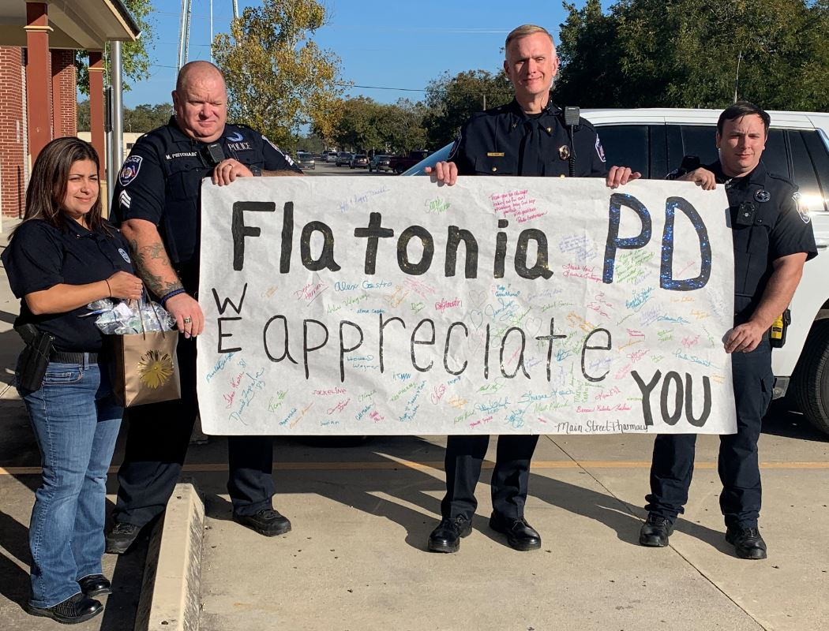
- Our police force is continuing to provide exceptional service to the community and was recently honored by the pharmacy and presented with a banner signed by each of the pharmacy staff as well as some treats for the officers to share. Pharmacy week was celebrated nation-wide October 18-24, 2020.

7. Public Services (Utilities)

  - Our Public Services staff are working diligently to clean up the front of City Hall. You’ll notice that the landscaping is manicured, and holiday decorations are going up a bit earlier than typical.
  - Flatonia City-Wide Clean Up was very well attended with a record number of roll-offs being filled.
  - In coordination with our water/sewer line repair grant, Supak construction is continuing work in the N. Converse alley. According to the contract this company has until mid-February to complete work although they seem to be moving along quickly. Staff is coordinating with TDS to ensure that trash service continues for all residential and commercial customers as well as delivery workarounds for impacted businesses.
8. Administration

  - Grant applications have been submitted with the CDBG General Land Office for Mitigation.
    - CDR17-0855 was submitted for conversion of the wastewater treatment facility to a mechanical plant. The total amount requested for this project is: $17,841,348.83
    - CDR17-0989 was submitted to address drainage concerns city-wide. The total amount requested for this project is: $24,693,175.60
Maps and additional supporting information for both grants are posted on the board outside of City Hall and are available in person and on the City of Flatonia website for viewing.

9. Other events and updates:

Past Events

The Flatonia Halloween event sponsored by the Flatonia PTO and held at the Civic Center was very well attended by Flatonia students and their families. Booths were arranged and staffed by local businesses, organizations and families and participants were socially distanced.

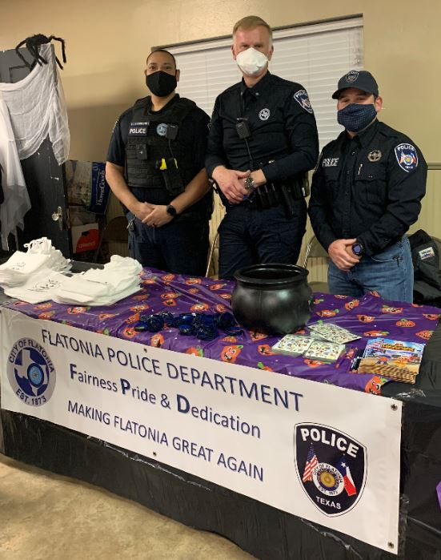

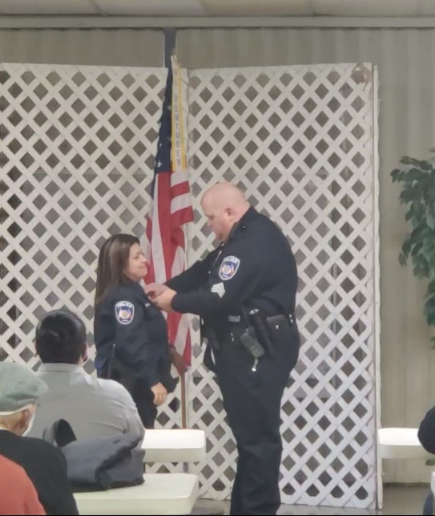
On Friday, October 30, approximately 30 people gathered in a socially distant manner to celebrate the promotion of Norma Pritchard to the position of Lieutenant within the Flatonia Police Department.

Upcoming Events

- Saturday, November 7th ,2020 Stew Dinner benefit for the will be held with pick up at the corner of South Main Street and Penn Streets.

- Friday, November 13, 2020 at 10:00 A.M. Darlin’s Diner Ribbon Cutting

- Tuesday, December 1, 2020 Lighting of Christmas Village at 6:00pm with Santa arriving on a Flatonia Fire Truck at the Downtown Parking lot! Social Distance photos can be taken with Santa! Refreshments and Christmas Music!

- Friday, December 4, 2020 - Wine Walk ~ 5:30 - 9:00 pm—Purchase a Wine Cup for $20.00 at the Chamber Office or C&M Liquor beginning Nov. 16th until December 4th at C&M Liquor. The walk begins at 5:30pm and we have ONLY 250 TO SELL! Participating Businesses will be practicing Social Distancing for Wine Samples & Shopping. Merry Market Arts & Craft Vendors Open 8:30PM.

- Saturday, December 5th, 2020 - Flatonia Civic Center – 208 E. N. Main St. – Merry Market—Arts & Crafts - 9:00 am - 4:00 pm Social Distance Photos with Santa- $5.00 @~ 10:00 am - 12 noon.

Flatonia City Council
November 10th, 2020 Council Meeting

DELIBERATION 11.1.2020.7

Agenda Item: Consider and take appropriate action on procedures and enforcement of the City of Flatonia Code of Ordinances.

