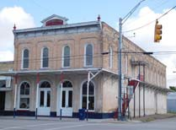

Individual Properties Listed in the National Register of Historic Places
in the Flatonia Commercial Historic District

1. 102 W. North Main Street. Known as the Arnim & Lane Building, this building was built in 1886 as a general mercantile store downstairs with an opera house upstairs. The architect was J. Riely Gordon, who later became known for his designs of Texas county courthouses, and Allert and Redmond were the builders. It served as an opera house only until 1896, but the mercantile store operated continuously under two generations of the Arnim family until 2001. Though no longer open for business, it remains full of merchandise – much of it taken into inventory in the 1940s.

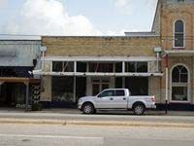
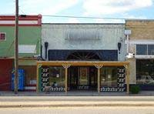
2. 102 W. North Main Street. This building was constructed sometime between 1906 and 1912 and served as an annex to the Arnim & Lane store next door from the day it was built until the store closed in 2001. It had a hand operated elevator which opened into the west side of the 2nd floor of the main building and was used to shift buggies and other large items between the floors. Eggs and grain for farm animals were bought and sold here. The building is currently used for storage.

3. 110 W. North Main Street. G. W. Allen, Sr. had the contract for the brick work and W. C. Turbeville had it for the wood work for this 1904 building, originally the G. C. Simmons grocery and produce store. It became a clothing store in 1915, first as Lauterstein’s for just a few years, followed by Fineman’s and then as Moe Klein’s from 1936 until 1976. Since then it has been used for clothing, antiques and gifts. Though now vacant, the interior of the store is currently being renovated and the owner plans to open it as a wine bar.
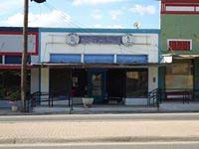
4. 116 W. North Main St. Built in 1913 by the Turbeville Brothers, the three buildings originally housed a produce store, a restaurant, and Jurica’s Cash Grocery. The produce store on the left became a Red & White Grocery in 1931, a Piggly Wiggly in 1936 and Bowdy Migl’s Grocery in 1957. In the 1970s, Migl took over the adjacent storefronts and joined them together as Migl’s Grocery Store. It is still operating as such by the Migl family today.

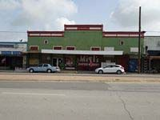
5. 120 W. North Main St. Built in 1928 by local contractor William Ungerer, this building was originally agricultural in nature; used for a short time for poultry packing. By 1931, it became used for retail purposes, starting with Vrana’s Tire & Accessory Store, and later, from the late 1930s through 1970, it was the Flatonia Gas Company, which sold butane and appliances. After 1970 it housed a couple of appliance and electronics stores, but since the late 1980s it has been a beauty salon.
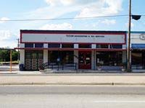
6. 124 W. North Main St. Though the Flatonia Lumber Company was organized and incorporated by local businessmen in 1907, this building dates to 1929 when it was constructed by local contractor William Ungerer to replace the company’s earlier frame building on the site. While the company’s lumber was stored in sheds across the street between Highway 90 and the railroad tracks, this building served as the business office and salesroom for construction supplies. After the Flatonia Lumber Company closed in the late 1980s, the building housed several hardware stores, and is now occupied by a bookkeeping / tax service.

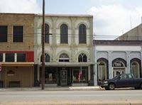
7. 103 E. North Main St. When the new town of Flatonia was established, J. M. Harrison and C. E. Lane moved from the nearby village of Oso and opened a dry goods and clothing store at this site on North Main. In 1881 the frame building was replaced by the current rock structure with Allert and Redmond as the builders. By the beginning of 1883 the store had been reorganized as Harrison and Arnim, then as J. M. Harrison and Sons in about 1886, before finally passing from the hands of the Harrison family in 1931, after which – in 1932 – the storefront was modernized. It became a variety store in 1935 and then from about 1964 into the 1980s, it was a Ben Franklin Store. Since then it has been used for antiques, real estate, and now a flower and home décor store.

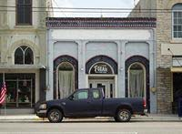
8. 105 E. North Main St. This brick-clad stone saloon replaced an earlier wooden saloon in 1891. A fixture in Flatonia’s early “wild west” culture, it was operated for several decades as the Southern Pride Saloon (also known as the Koch Brothers Saloon). Later, from approximately 1930 to 1964, it was used as a meat market. It still has a large walk-in cooler with graphic advertising from its meat market days, but it is now a screen printing tee-shirt shop.

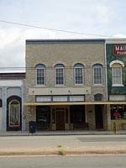
9. 107 E. North Main St. This building and its neighbor at 109 E. North Main, known together as the Wolters Building, were built in 1880. Originally leased by Bennett & Holloway for sales of groceries and medicines downstairs with a hall for dances and other entertainments upstairs, by 1881 it, along with the adjacent Wolters building space, was identified as Heard, Tuttle & Holloway, dealing in general merchandise. By the end of the 19th century, the downstairs proprietor, in addition to selling groceries and “notions,” introduced a café into the space. Felix Brunner bought the restaurant in 1926, renamed it the City Café and modernized the storefront in 1934. Servicing locals and travelers on The Old Spanish Trail / Highway 90, the café was a fixture in town, operating through 1975. Since then the building has housed a bar and an internet service provider; the downstairs is currently used as storage and the upstairs a law office.

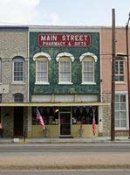
10. 109 E. North Main St. Built in 1880 along with 107 E. North Main as the Wolters Building. By 1881 both sides were leased by Heard, Tuttle & Holloway as a general store. That same year, the Flatonia Argus moved to the second floor. In 1884, the first level became Pellar’s Drug Store and it has remained a drug store to this day under various owners, with the storefront being modernized in 1930. The 1885 Sanborn map identifies the upstairs as a printing office. In the 20th century, the back room of the second floor was used as a lodge hall—first for the Knights of Pythias, then by the Flatonia Rotary Club from its organization in 1940 through 1971. The front part of the second floor became a doctor’s office from the 1920s until about 1968. Today, the second story is used for storage.

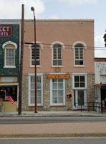
11. 111 E. North Main St. This building was built in 1879 by Anton Freytag and was owned and operated by C. Stoffers as a harness and saddle shop, with a lodge room for the Masons and later the Knights of Pythias on the second floor. By 1909 it became the home of the newly organized State Bank, the city’s second bank. In 1916 when State Bank merged with First National Bank of Flatonia (becoming Flatonia State Bank) the bank moved across town, but returned to this building in 1923, staying until 1927 when new quarters were built on the corner of N. Main and Penn (#7). During the period 1910-1927, the second floor was occupied by the Southwestern Bell Telephone Exchange. The building remained vacant and used for storage until the late 1950s when E. A. Arnim Jr. made the ground floor his law office, which it continued as until his death in 1978. During Arnim’s occupancy, the upstairs housed an insurance company. Thereafter the building became a part of the E. A. Arnim Archives & Museum, an antique store, a law office again, and finally now is a photography studio.

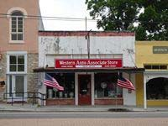
12. 113 E. North Main St. Constructed in 1880, this building housed one of Flatonia’s many early saloons, J. Lieck’s Sunny Side Saloon, and continued to be listed as a saloon on several Sanborn maps, but by 1922 it had become a meat market. In 1929 it was remodeled by local contractor William Ungerer and was occupied by the offices of Central Power and Light. It became a Western Auto store in 1946 and continues to operate as such to this day.

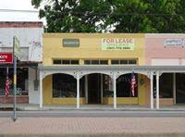
13. 115 E. North Main St. One of three identical buildings constructed between 1922 and 1930, its first known use was the Jim Starry Grocery, which operated though about 1969. In the late 1970s it housed a gift shop, but then fell vacant for several decades. The left side has been an architect’s office since it was renovated in about 2004, while the right side provides a passage to a courtyard with business bungalows for lease.

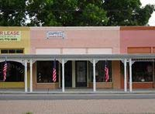
14. 117 E. North Main St. The central of three identical buildings constructed between 1922 and 1930, this one was divided into two shops, with the space on the left occupied by Gray’s Barber Shop from the time of its construction in the late 1920s for more than 50 years. The original use of the right side of the building is uncertain but may have been used for street side access to Bill Miller’s Dry Cleaning service. By 1960 it was occupied by a watch repair shop and continued to operate as such into the 1980s. After the barber shop closed, the left side of the building then housed a liquor store for some years, but is once again used as a barber shop. The right side housed an electronics store but is now a day beauty spa.

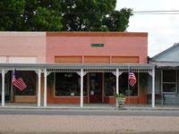
15. 121 E. North Main St. One of three identical buildings constructed between 1922 and 1930, this building is believed to have been Berger’s Grocery for a few years following its construction, but by 1932 it was the Style Shop, a ladies clothing store. By 1969 it had become the Smart Shop and continued to sell ladies’ clothing in this location until it closed in about 2005. Since then it has housed a couple of antique shops. It is currently being rented by a building contractor.

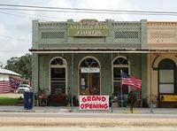
16. 127 E. North Main St. This building dates from 1897 when it was built by contractor Pat Redmond – along with the identical buildings on either side – following an 1895 fire that had destroyed several frame buildings at this end of the block. The building has hosted a long list of retail tenants over the years. On the 1901 Sanborn map it is shown as a “Notions” store, on the 1906 map it is identified as a general store, and in 1913 it was opened as a dry goods and clothing store, but after it moved to another building on North Main in 1915, it became a racket store (a predecessor to the five-and-dime) in 1921. From 1930 into the 1940s, it was a grocery store. It subsequently became a hardware and plumbing store and operated as such until about 1973. Since then it has housed a carpet store, an automobile supply store, a tea room and currently a craft and antique store.

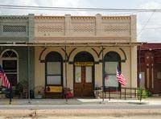
17. 129 E. North Main St. Like the building at 127 E. North Main, this building was built in 1897 by contractor Pat Redmond. It was first occupied by a grocery store, but by 1902 it became a drugstore operating under several different owners with an assortment of doctors all having offices at various times in the store as well. In the 1940s, busses traveling Highway 90 started using this location as their Flatonia stop. By 1950, no longer a drugstore, it was operated as a recreation hall/bar/bus stop and continued as such until about 1977, when the bus stop was moved to a new gas station/convenience store on Interstate 10. Since then it has been a dance studio and though vacant for some time, now houses the office of a portable toilet company.

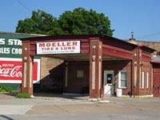
131 E. N

18. 131. E. North Main St. This building was constructed in 1931 as a Gulf Service Station by contractor William Ungerer using a plan provided by the Gulf Refining Co. It was the second stand-alone filling station constructed on the Flatonia section of the Old Spanish Trail / Highway 90. It became a Humble Station in 1936, and at some point a Mobil Station, during which time the canopy sported a large Pegasus, the company’s flying red horse logo. Perhaps because of competition from the two new gas stations a couple blocks east, the Mobil Station closed in 1958, but was reopened in 1961 by Elton Moeller. In the late 1990s the Moeller family changed it to Moeller Tire & Lube – removed the gas pumps and Pegasus – and it continues to operate in this capacity today.

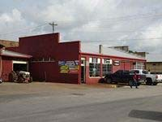
19. 131 E. North Main St. The building was built by contractor William Ungerer in 1931 for O. L. Lee’s Chevrolet dealership and garage. Sometime in the 1940s, the business was taken over by Brasher Motor Company, a Chevrolet dealership with several locations in the county. It passed through several more hands until Elton Moeller, who had the Mobil station on the corner, took it over in 1971. It has continued as a part of the Moeller garage business since that time.

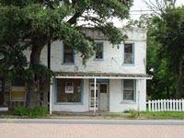

20. 223 E. North Main St. A Mr. Moore was the contractor who built the 20 room Polasek Hotel in 1932 to serve people traveling on Highway 90. While continuing to operate as a hotel, by the 1940s a separate entrance on the left side of the building gave access to a liquor store. It is uncertain how long it continued to function as a hotel, but by 1967 the liquor store was operating as Kelley’s Package Store and this continued to operate at least until 1988. Since then the building has sometimes been used as a residence, but it is currently vacant.

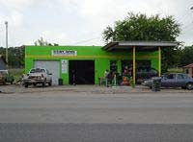
21. 302 E. North Main St. This filling station was built in 1949 on Highway 90, not long after the new federal highway opened in Flatonia. It was a company-controlled Gulf Oil station, operated under two different owners, until about 1978, when gasoline services shifted from Highway 90 to I-10. Since then, and to the present day, it has been used as a garage under various owners.

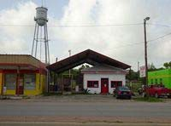
22. 306 E. North Main St. Built as Wotipka Bros. or Tip’s Texaco Station in 1925, just as the business district was expanding to the east along the recently designated highway known as the Old Spanish Trail. It was the first filling station on the Flatonia section of the Old Spanish Trail. In 1952 it was converted to a café known as the Cozy Café and continued to operate as such until about 1977. After that it served for some time as an insurance agency, but is once again a restaurant.

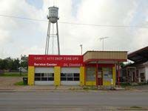
23. 312 E. North Main St. This was built as Niemann’s Service Station in about 1952, selling Texaco products and replacing the earlier Texaco station next door at 306 E. North Main. It continued to operate as a Texaco gas station through the 1980s under successive owners. It has been used as a garage since then, but is presently vacant.

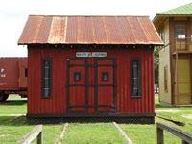
24. 100 Block of West South Main St. The calaboose was built in 1890 as an improvement to previous jail accommodations and was located northeast of the Justice of the Peace Courthouse (#79) along the alley between South Main and Sixth Streets. In 1952, the two cell building was moved as a result of citizen complaints regarding prisoners’ noise but continued to be used for overnight lockups until the early 1980s. In 1984 it was moved to its present location to be maintained as a historic building. Featuring prisoners’ graffiti dating as far back as 1900, the Flatonia calaboose is just one of two known extant calabooses in the county.

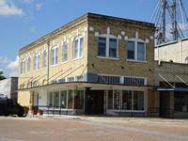
25. 101 W. South Main St. The Wheeler Building was built in 1907 by Allen Brothers Construction for W. H. & Emma Wheeler, two of Flatonia’s most prominent citizens / local business owners from the city’s early days. This building was first occupied as a dry goods store downstairs and the Wheeler’s son, a dentist, Dr. L. A. Wheeler had an office upstairs from 1911 to 1959. It is one of just a few buildings in town to have a basement. The first floor has housed a number of different tenants, among them a grocery and hardware store (beginning 1917), a grocery and dry goods store (from 1919), and a dry goods and clothing store (from 1921). Starting in 1936, it was used for some time as a feed store under two different owners. In 1964 the upstairs was used as Flatonia’s first nursing home, while the downstairs continued to house various retail establishments. In 1975 the upstairs was converted to residential, while the downstairs became an antique store. Today the building houses the offices of a beef distributor. The building became a Recorded Texas Historic Landmark in 1989 (marker #5778).

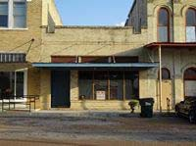
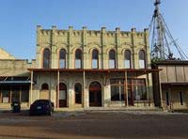
26. 105 W. South Main St. Built in 1920 as Citizen’s Auto Supply, it was a showroom for Ford cars and supplies, and the first purpose-built automobile dealership in Flatonia. Though the Ford dealership moved across town in 1924, the building continued to be used as a garage at least through 1949. It was then used only for storage until the 1980s when it became an antique store. Though currently vacant, the interior is being renovated and the new owners plan to open a bar.

27. 109 W. South Main St. Dr. G. W. Allen Sr. had this building erected in 1897 to serve as the city hospital. The second floor hospital obtained its water supply from a rooftop windmill and cistern, which was removed in 1914. The hospital was in operation only until about 1905 and from about 1911 through 1923 the second floor served as Flatonia’s third opera house, hosting traveling vaudeville shows, local talent dramatic performances, high school graduation ceremonies and mass meetings. The ground floor has been occupied by a number of tenants through the years, including a grocery store, a drug store, a jeweler, a millinery shop, a skating rink, an auto repair shop with a fuel pump, a print shop, and a hatchery. From the 1950s at least through the mid-1980s it housed the Flatonia Flour & Feed Store. It has also housed a custom boot shop and an antique store in more recent times. The upper floor is rented as apartment space. The building became a Recorded Texas Historic Landmark in 1983 (marker #1908).

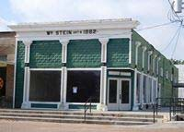
28. 102 E. South Main St. This building was constructed in 1915 as a hardware store for William Stein to replace an earlier frame Stein Hardware store that had occupied the same lot. It continued to operate as Stein Hardware from the day it was built through about 1974, after which time the building has been used by a flooring store, a hair salon, and a number of antique stores. It is currently vacant.

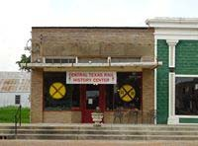

29. 104 E. South Main St. This building was constructed in 1929 by contractor William Ungerer for Joe Prihoda as a shoe repair shop. By the 1940s it had become the Jullé Beauté Salon and continued to operate as such until the late 1970s, after which time it has housed a gift shop, a childcare center and an insurance agency. It is currently the Central Texas Rail History Center.

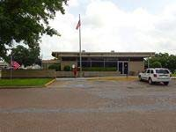
30. 105 E. South Main St. After a 1969 land transfer from the Southern Pacific Railroad to the City of Flatonia, this building was constructed by local contractor Frank Prihoda for the City of Flatonia under a plan to lease it to the Federal Government as a U.S. Post Office. The City of Flatonia sourced the materials for construction. It has been used continuously from the time of its construction in 1970 to this day as the Flatonia Post Office

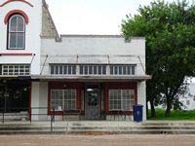
31. 112 E. South Main St. Built in 1913 for W. P. Harrison as the Crystal Confectionery, this building became a barber shop and tailor shop by 1915. It continued to serve as a barber shop at least through the late 1930s, then housed several tenants including the Flatonia Post Office in the late 1960s for some years before the new one across the street was completed in 1970. Since then it has housed an expansion of the furniture store from next door, home health care, a carpet store, and a tax preparation service. It is currently vacant.
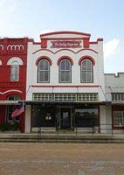

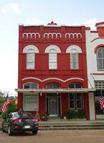
32. 114 E. South Main St. This building was constructed in 1887 and the first floor was used for the Fernau Furniture Store. Before a funeral home was built in Flatonia, the Fernaus had an undertaking/casket business on the second story. The Fernaus continued to operate a furniture store in this location from the time it was built until about 1972. Since that time it has housed a variety of tenants, including another furniture store, a music store, a book store, and an antique store/café. It is currently vacant.

33. 116 E. South Main St. This building was built in 1901, reportedly by a San Antonio-based architect and builder Pat Redmond, and is the second of the extant buildings in town to serve as Flatonia’s post office. It continued to serve in that capacity from the time it was built until the early 1960s when the post office moved and it became a doctors’ office for just a few years and then a boot and saddle repair shop from about 1965 until about 2000. It has also housed an antique/gift shop but is currently residential.

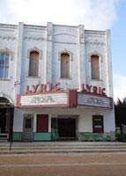
34. 120 E. South Main St. Constructed in 1879 for E. H. Fordtran by Robert Allert and William Turberville of locally manufactured bricks, this building is the oldest brick structure in town. The ground floor was originally Renfro & Routh drug store, in 1885 a mercantile store, and by 1901, a grocery store. The top floor was originally a public hall and served for a number of years as Flatonia’s City Hall, but by the 1890s it was used for dancing classes, and from 1892 to 1893 by a business college. In 1913, the building became the “winter quarters” of the Happy Hour Theatre (in the summer months, before air conditioning, movies were shown outdoors at the “Airdome”—a vacant lot at 128-130 E. South Main where a projector and seating was set up to show movies during the heat of the summer season). In 1930, the name of the movie theatre was changed to the Lyric, during which time the building’s signature marquee was added and the façade renovated. It continued to serve as the Lyric Theatre until it closed in 1967. Since that time it has been mostly vacant but is currently open sporadically for live theatre and the owner plans to begin showing movies again.

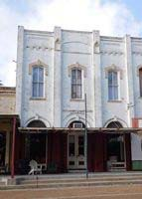
35. 122 E. South Main St. This building was constructed in 1880 by Allert & Redmond for E. H. Fordtran. The first occupant was G. A. Steinle, who opened a dry goods and millinary store there in 1881 under the name of Steinle’s Bazar. The 1891 and 1896 Sanborn maps show it as a general store. In 1901 it was a saddlery and the second floor was used for printing. By 1906 it was vacant again, but later was a jewelry store (c. 1910), and then by 1912, a dry goods and clothing store. In 1913, when the Happy Hour Theatre moved in next door, it became a grocery store and in 1931 the second floor began to be used by a company that created stage curtains. The grocery store continued to operate under different owners into the 1980s, and thereafter it was used for a number of years as a café. Currently the building houses a cabinet shop downstairs and loft apartments upstairs.

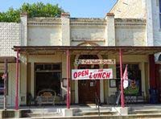
36. 124 E. South Main St. This masonry building was built at the same time as its neighbor at 122 E. South Main by Allert & Redmond. Constructed for Postmaster Adolph Wenmohs, it replaced Flatonia’s first post office, which was a wood frame building. In addition to serving as the post office, the building also housed a druggist and a jeweler until it became First National Bank of Flatonia in 1890. As Flatonia’s first incorporated bank, it played an important role in the town’s development. When consolidated with Flatonia Bank in 1916 to become Flatonia State Bank, it continued to operate in this location until 1923. It then became H. Thulemeyer’s jewelry store, at which time the storefront was updated with plate glass windows. By the late 1940s, half of the store was occupied by an optometrist who continued his practice there into the mid-1980s. When Thulemeyer’s closed in about 1960, the other side continued as a gift shop until 1971. Since then it has housed a variety of tenants, including a café, and it currently operates as a restaurant.

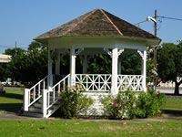
37. 125 E. South Main St. Built as a band stand, also known as the gazebo, in about 1911 and located in the city park not far from the intersection of E. South Main and Market, this was the site of many outdoor concerts and meetings of the ladies’ Shakespeare Club. It was moved to the city cemetery sometime after 1952 and moved again in 1996 to its current central downtown location near the railroad tracks.

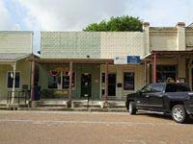
38. 128-130 E. South Main St. This building was constructed sometime between 1922 and 1930 on the former site of the open “Airdome” movie theatre. The building served as the Flatonia Argus office until 1934. Since then it has housed a variety of tenants, including electric repair services, a beauty shop, real estate agents, insurance agents, and antique stores. It is currently occupied by a trophy and engraving store, as well as a realty office.

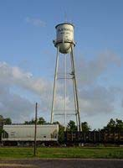
39. 300 Block of E. South Main St. This elevated water tower and the pump house were constructed in about 1926 following passage of city water and sewage bonds. Although two additional water towers have

Photo 20
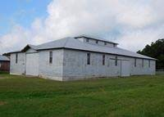
since been erected on the outskirts of town, this tower is still on line and provides drinking water to the citizens of Flatonia to the present day. A siren, located on the property and dating to the period of significance, sounds daily at noon to signal the lunch hour.

40. 100 Block of S. Faires St. This building was moved, or at least the materials were moved and reconstructed by the same design, from the Flatonia Fair Grounds southwest of the city in about 1942. It was used during World War II to make ammunition boxes and wooden cases for mine detectors and radio supplies. After the war and into the 1950s, owner Andrew Eidelbach began to use the building to construct pre-fabricated houses which were used by returning military personnel and their families near bases in San Antonio. When no longer used for that purpose, the building has since been used for storage and warehousing, just as it is today.

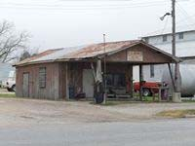
41. 100 Block of S. Faires St. The building was constructed sometime between 1901 and 1906 according to Sanborn maps, although it was reported to be vacant on the 1906 map. By 1912 it is identified as an auto repair shop. It was one of Flatonia’s earliest free-standing filling stations on what became the second of its major roadways for automobiles, Highway 95. It continued to function as a filling station into the 1970s, but now stands vacant.

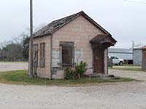
42. 100 Block of S. Faires St. This small building was constructed sometime between 1901 and 1906 to serve as an office to the Eidelbach Cistern Factory. It continued to serve the Eidelbach concern as an office through several generations and several permutations of their business until Eidelbach Lumber Co. closed in about 1975. Since that time the building has been vacant.

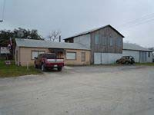
43. 100 Block of S. Faires St. This building, constructed in about 1882 for Andrew Eidelbach Sr., housed one of Flatonia’s first small industrial concerns. It was a cistern factory, planing mill, and grist mill for many decades until the early 1940s when it became a government defense plant, producing wooden cases for on-site packing of war materials like ammunition, mine detectors, and radio supplies. In 1957 the third generation of Eidelbachs started a lumber yard here and continued in that business until 1976. The lumber business moved to a new location, but the property was acquired by S & S Grain, a local trucking enterprise, and continues to operate as such today.

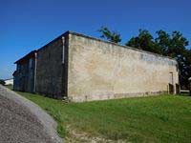
44. N. Hudson & Seventh St. Built between 1922 and 1928, this building was the cold storage unit for Southern Produce Co., a large processing plant for turkeys and other poultry. Southern Produce continued to operate out of this building until about 1970, after which this building has only been used for storage.

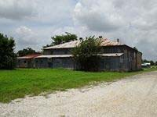
45. N. Hudson & Seventh St. This building was the actual processing plant for Southern Produce and was constructed sometime between 1922 and 1928. In addition to dressing and packing poultry, eggs were candled and packed for shipping. Southern Produce was in operation until about 1970 and the building has only been used for storage since then.

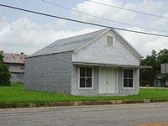

46. N. Penn & Seventh St. Built sometime before 1885, the Sanborn Map for that year identifies this building as part shoemaker shop, part dwelling. It later became a restaurant and then a warehouse. By 1922 it was a tin shop, possibly as an extension of the larger tin shop that was once adjacent to it. Still identified as a tin shop on the 1940 Sanborn map, it is uncertain how long it continued to be used as such. It is now vacant.

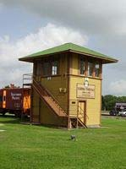
Flatonia To

47. 100 Block of South Penn St. This building was constructed by the Galveston, Harrisburg & San Antonio Railroad in 1902 to serve as a switching tower at its intersection with the San Antonio & Aransas Pass line. Texas began its numbering system for rail switching towers in 1901 and Flatonia’s was number three after that date. It remained in active service from its construction until 1996 when it was decommissioned by Southern Pacific, shortly before the company’s takeover by Union Pacific, and by that time it was the last of its kind still operating in Texas. It was moved to its present location to save it from destruction. It is now owned by the E. A. Arnim Archives & Museum of Flatonia and open for viewing by rail fans through the Central Texas Rail History Center of Flatonia.

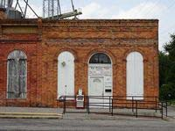
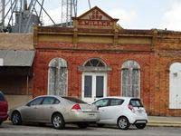
212 S. Penn is
48. 212 S. Penn St. This building was constructed c. 1886 and has had several different uses over the years. It was initially used for the manufacturing of buggies, wagons, and plows, and later became a harness shop and then a grocery store. By 1940 it is identified as a beer warehouse on the Sanborn map. From the mid-1960s until 1978 it was a barber shop, at which time it became a part of the offices of the Flatonia Argus, which was located next door at 214 S. Penn, and is still operating as such to this day.
49. 214 S. Penn St. C. Stoffers, the saddle and harnessmaker who had his shop at 111 E. North Main, had this building erected in 1886. For several decades, the building was home to a variety of retail establishments, including a grocery store, a general store, and later a variety store. Starting in 1934, the Flatonia Argus newspaper occupied the space. The Argus, which was first published in Flatonia in 1878 and had moved several times in its history before 1934, made this location its permanent home and is still operating here to this day—the longest continuously published newspaper in Fayette County.
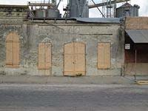
50. 218 S. Penn St. This building is the oldest rock structure in town and was built in 1876 for merchant H. W. Yeager. An ad from 1883 supports the 1876 construction date by naming it as “The Centennial Rock House.” When this and the adjacent building at 220 S. Penn was operated as H. W. Yeagers Sons, this half of the business was dedicated to the sale of stoves and tinware. Later tenants included a hardware/grocery, a wholesale grocery, and the Flatonia Argus office. By 1917 and at least through 1930, it was once again occupied by a wholesale grocery company, this time the Alexander Grocery Co. From about 1946 through about 1956, this building along with its neighbor at 220 S. Penn, became George Vrana’s feed store. It then continued as a feed store under various owners, including Carl Smith as a part of his Smith Farm Egg enterprise. It is now owned by Cal Maine Foods (the nationally known egg producer that acquired Smith Farms) and is used as a feed warehouse.

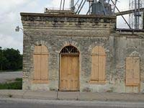
51. 220 S. Penn St. This building was constructed in 1880 by Allert & Redmond as an addition to the H. W. Yeager store at 218 S. Penn, with this building dedicated to selling general merchandise. By 1906 part of the wall between this building and its neighbor was removed and both buildings were used for a wholesale grocery business. Between 1910 and 1913 the building operated independently as a meat market and then a grocery business again. As of 1917 and until at least 1930, it was again joined with 218 S. Penn as a wholesale grocery under the Alexander Grocery Co. In about 1946 it became a feed store and continued as such under various owners, including Carl Smith as a part of his Smith Farm Egg enterprise. It is now owned by Cal Maine Foods (the nationally known egg producer that acquired Smith Farms) and is used as a feed warehouse.
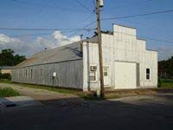
52. 213 S. Penn St. This building was constructed sometime between 1930 and 1940 and was used as Freytag’s welding and machine shop from the time it was built through the mid-1990s. It is now vacant.

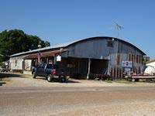
53. 122 E. Seventh St. The building was constructed in 1924 by contractor William Ungerer for the Alexander Wholesale Grocery Company. Originally used for grocery warehousing, it began to be used by different entities as warehousing for flour and feed by 1929, including Nikel & Sons trucking and grain business, which took over the space in about 1952. In 1982 it became a retail feed store, at which time it was one of seven in Flatonia, and it is the only one that remains open and operating to this day.

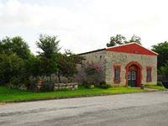
54. 117 E. Sixth St. According to Sanborn maps, this building dates from sometime between 1896 and 1901 and was the last of the native stone buildings to be constructed downtown. It served as the warehouse for the Fernau Furniture store (just to the north at 114 E. South Main) from the time it was built well into the 20th century. By the latter half of the century it was largely unused. In 1998 it was converted to its current use as a saddle and gift shop with living quarters in the rear.

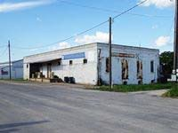
55. 118 N. Market St. This building was constructed by local mason Harry Beale in about 1906 for the Cowdin Wholesale Grocery Company which continued in operation into the 1940s, after which time it was taken over by Groce-Wearden wholesale grocery company. In the 1950s it was used for a few years to raise minks and to house caged laying hens. In the 1960s and 70s it was used as storage space. From 1982 through 1998 it housed City Feed & Produce Company. It is currently vacant.

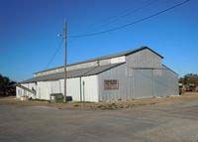
56. 206 N. Market St. This building was constructed sometime between 1922 and 1930 as a part of the Flatonia Crate & Box Factory, which continued to operate until 1967. It was then used as warehousing until 1976, after which it became the office and warehouse space of Mica Soil Service and it continues to operate in this capacity to the present.

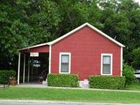
57. 214 S. Market St. Constructed in 1893 with “Messrs. Chambers and H. Moeller” acting as contractors, this building was a meat market into the 1920s. Its exact use thereafter is unknown, though it was still marked as a store on the 1930 and 1940 Sanborn maps. In the 1940s it was converted to a residence with a part of it serving as a beauty shop which continued to operate until about 1956. It was then used as a rental property and residence until about 2010. It is now rented as an annex of the Olle Hotel next door.

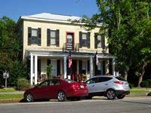
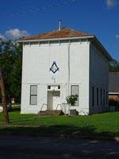
story openings have been e
58. 215 S. Market St. This building was built in 1888 as a Justice of the Peace Courthouse on the ground floor and a Masonic Lodge Hall on the second floor. Possibly from the time it was completed – but definitely by 1891 – the first floor was also used as Flatonia’s City Hall. The bell which used to be in a belfry on top of the building was rung when there was a fire in town until the siren on top of the water tower began to be used for that purpose in about 1926. The ground floor continued to serve as the courthouse / city hall until new facilities were built for each in the 1980s, at which time the Masons moved their meeting hall downstairs. The building is currently owned by the Masons and has been used for their meetings from the day it was constructed until now.
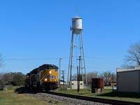
59. 218. S. Market St. This two-story brick structure was built in 1901-1902 as a residence for Flatonia physician G. W. Allen Jr.1 When the Central Hotel on South Main burned in 1915, its former manager Carrie Snell purchased this building to operate as a hotel. With the St. Louis Hotel already gone, and now the Central, Flatonia would still have two sizeable boarding houses/hotels needed to lodge the many drummers, or traveling salesmen traveling by rail. In 1926 Otto Olle purchased the hotel and it was operated as the Olle Hotel, largely by his wife Agnes, for more than 30 years until her death in 1967. It then remained vacant until 1999 when it was reopened as a bed and breakfast. In 2004 it was opened again under the name of the Olle Hotel and continues to operate as a hotel to this day. The building became a Recorded Texas Historic Landmark in 2009 (marker #15738).
60. Union Pacific Railroad. The earliest permanent structure in Flatonia was this track for the Galveston, Harrisburg & San Antonio Railroad and the first train arrived in April of 1874. Known as the Sunset Route from its earliest days, trains continue to use these tracks to the present day. In 1934 the G. H. & S. A. was absorbed into the Texas & New Orleans line, eventually becoming a part of Southern Pacific and finally Union Pacific.

